Simple Automatic Passenger Counting Syste (SAPCoS)

Somchoke Ruengittinun and Disorn Tantigate

Computer Science Department, Faculty of Science, Kasetart University
50 Ngam Wong Wan Rd, Ladyaow Chatuchak,
Bangkok, Thailand
somchoke.r@gmail.com, disorn.t@ku.th

Abstract

In every flight, the airline crew usually take many times to count number of passengers before their aircraft takes off. As there are some conditions to be met before counting. One of which is that all the passengers need to be in place and this usually takes some time. Furthermore, the airline crew often need to perform the counting procedure again and again to fortify the exactness of the counting. In this paper, IoT was introduced with a simple model of automatic passenger counting in which will call “Simple Automatic Passenger Counting System” or SAPCoS to make the passenger counting procedure more concise. SAPCoS can operate with sensors called force sensitive resistors or FSRs, and mount them under all passenger seat cushions in the aircraft. The system will get values from the sensors to determine whether each seat is occupied or not and also summarize all the data into a report showing present and absent passengers. After testing the model, the system performed the way as expected it to in general cases, but from our inspection, there were several factors that may have affected the accuracy and reliability of the system, such as the passenger’s weight, seating position, sensor mounting location and so on. Thus, the model needs to be improved by addressing those reliability issues in the future.

Keywords-component; Automatic passenger counting, FSR, Force sensitive resistor, IoT, Adruino

I. Introduction

In aircraft, as stated above, there is one important task for flight attendants to perform before taking off, getting the passenger count. This task is time consuming and needs to be done frequently. Frequently performing this task on large vehicle is not a small insignificant on. SAPCoS connects all sensors to a microcontroller to translate data from the sensors to a computer. The system needs to be triggered by a crew member in order for it to start counting; and it will completely shut down before the vehicle takes off. SAPCoS will not interfere with any flight instruments whatsoever. The system will provide convenience, reduce the crew’s burden and chance of error. In addition to that, the system only needs a single member of the crew to operate, and can operate as soon as all the passengers are in place.

II. RELATED WORK

There are many different methods that used for automatic passenger count. Most of them cannot recognize passengers or link to passenger database to identify passengers. For example,
some people have implemented a system for counting people and have used it in public transportation vehicles [2]. The approach used in that system consisted of using a stereo vision system installed over the vehicle doors along with a featurebased counting algorithm and an object tracking system to count people coming in or getting out the vehicles. This system is not suitable for counting passengers on an airplane because it cannot recognize or identify onboard and offboard passengers. In contrast, the system was introduced in this paper uses passenger information which already exists in a database that has been gathered from the check-in process. The system then matches the data collected from sensors mounted under the seats to the information in the database.

III. SYSTEM OVERVIEW

The automatic passenger counting system comprises of 3 major components that work together: force sensitive resistors (FSRs), a microcontroller and operation software. Each sensor is responsible for determining the existence of individual passengers by sensing their weight applied to the seat. Hence, requiring the sensors to be mounted on every passenger seat on the vehicle. All components are connected to each other by wires so that there are no wireless signals which can interfere with the flight instruments. The FSRs do not generate any electromagnetic interference (EMI).
The counting process starts when a crew member triggers the system to start counting. As the system starts, it will send a pull command to the microcontroller in order to start reading output values from the sensors. When the microcontroller acquires the output values from the sensors, it will forward the values to the managing software to process the values and determine whether the passengers exist or not. In practical use, SAPCoS can install more than one microcontroller due to the limitation of analog input pins on the microcontroller; the pins used for receiving signals from the sensors. In our prototype, the Atmeta328 microcontroller which is on the Arduino UNO R3 development board. The board has 6 analog input pins that can connect up to 6 sensors to a microcontroller. Each microcontroller needs to communicate with each other through a link protocol like I2C. Each microcontroller has to pass pairs of values read from the sensors along with seat numbers assigned to each sensor, to a
microcontroller that connects to the managing software. The managing software will then process the data from the microcontroller through its algorithm which uses a threshold value to determine the existence of a passenger.

IV. FORCE SENSITIVE RESISTOR

The sensors in the system are force sensitive resistors (FSRs). that will be using Interlink model 406 FSRs which can detect physical pressure, squeezing and weight. In practical use, any size of FSR can be used, but the larger the sensors are, the more accurate the system will be. An FSR is basically a resistor that is made of robust polymer thick film (PTF) and changes its resistive value depending on force applied to the surface of the sensor. They are suitable for detecting rough weight values, but they are not precise enough to measure weight accurately. The resistance value of the sensor will be greater than 10 MΩ with no force applied and decreasing as the force is applied to the sensor[3]. In addition, the sensor generates no EMI while it is operation which means there is no electromagnetic interference generated from the sensor. The relation between the resistive value and force applied to the FSR is as shown in Fig 2.

Fig.1 shows the physical dimensions for the sensor. The sensing area is 39.6 x 39.6mm., and the thickness of the sensor is 0.46mm. Each layer of the force sensitive resistors are made of the following material and thicknesses: semi-conductive layer [Ultem] 0.13mm thickness, spacer adhesive [Acrylic] 0.15mm thickness, conductive layer [Ultem] 0.13mm thickness, rear adhesive [Acrylic] 0.05 thickness. Since the sensors comprise of multi-layer material, they cannot tolerate much shear force. Appling excessive shear force can cause delamination of the layers. Bending of the sensor can lead to erratic readings, but in our case, the slight bending will not affect the accuracy of the sensor.

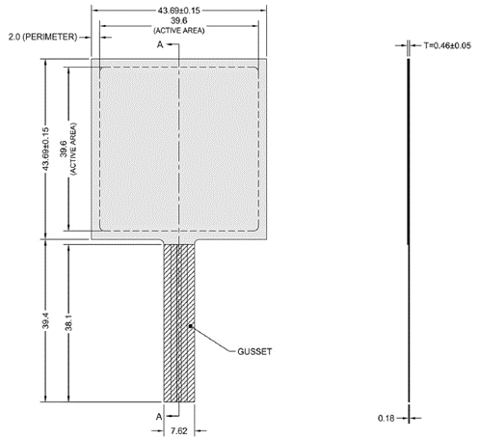

Fig.1 FSR Interlink model 406 dimensions [2]

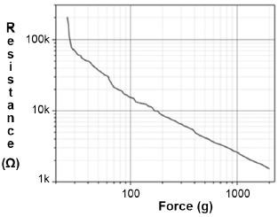
Fig.2 Relation between resistive value and force applied to the FSR [3]

The FSR is designed to measure the resistive value in a voltage divider where the voltage output can be found by using the following equation. [3]
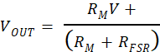

The FSR can be connected as shown in Fig.3 where V OUT connects to the analog pin of the microcontroller, V+ to a 5V power supply, and the RM resistor will be used for tuning the VOUT value. The relation between RM and VOUT are shown in Fig 4.

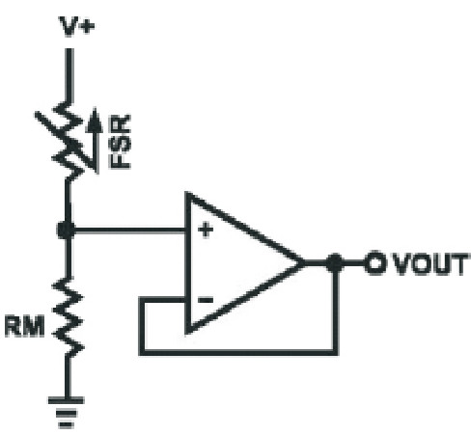

Fig.3 Circuit diagram of FSR in voltage divider [2]

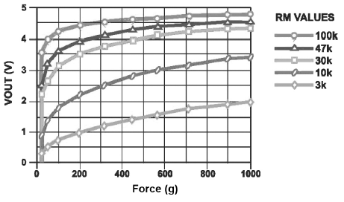
Fig.4 Voltage output with different R_{M} values [4]

V. MICRO CONTROLLER

The microcontroller in this project is used to read output values from the force sensitive resistors. In the prototype, with an Arduino Uno R3 development board which uses the Atmel ATmega328 microcontroller. The specifications for this model are shown in Table I. The microcontroller has 6-channel 10-bit A/D converters, that can connect up to 6 force sensitive resistors. Each microcontroller needs to be programmed to receive data from the sensors and forward the data to other microcontrollers. If it is the main microcontroller it has to send the data to a laptop and needs to define which sensor belongs to which seat number. The microcontroller will map the sensors that are connected to its analog pins with seat numbers that are setup in the microcontroller. So, the data sent out from the microcontroller will consist of pairs of variables: seat numbers paired with their corresponding sensor values.

TABLE I [1]
THE SPECIFICATIONS OF ATMEGA328
Keys | Parameters
CPU type | 8-bit AVR
Performance | 20 MIPS at 20 MHz
Flash memory | 32 kB
SRAM | 2 kB
EEPROM | 1 kB
Pin count | 28-pin PDIP, MLF, 32pin TQFP, MLF
Maximum operating frequency | 20 MHz
Number of touch channels | 16
Hardware QTouch Acquisition | No
Maximum I/O pins | 26
External interrupts | 24

VI. SAPCoS Architecture

In the system architeture aspect, as seen in Fig.5, the microcontroller will send sensor data to the software, the software will analyze the existence of passengers from the value it receives. The values that are sent and forwarded to the software comprise of pairs of variables: seat number and sensor value. After the software has determined the existence of each passenger, it will store the existing passengers in a database along with the personal data of each passenger already existing in the database to make a new list of information.

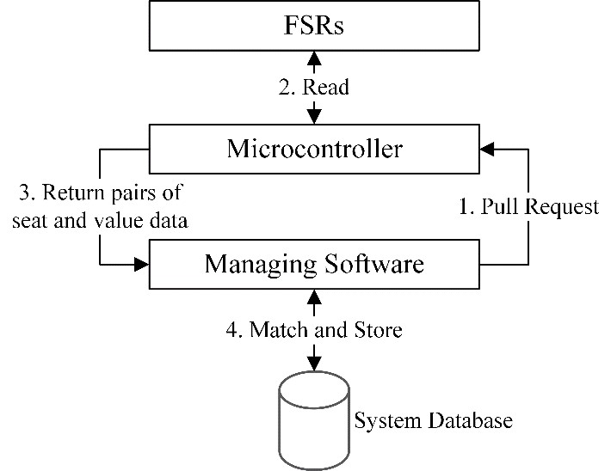

Fig.5 System Architecture

The algorithm used in the software to determine whether passengers are present works by comparing sensor data to the threshold value that is pre-set in the software. By adjust the threshold value to determine the existence of the passengers more precisely based on other factors in the system such as the thickness of the seat cushion. The output of the software produces lists of present and absent passengers on that flight.
Crew members can also check the names and status of both the present passengers and other passengers who have provided information since the check-in process. The managing software was built using Java to allow it to run on a laptop connected to the main microcontroller to receive all the sensor output data.

VII. MODEL TESTING

In our test model, tested the components which consisted of force sensitive resistors and a microcontroller with the following environment. By attached the force sensitive resistor sensor under 3-inch thick cushion to simulate a flight seat and place the cushion on a hard-flat surfaced chair. The surface area is 35 x 40cm. Installed the sensor in the center of the area under the cushion. To ensure whether the sensors can perform as expected, many objects were placed on the cushion to simulate passenger weight and read the values from the sensor. Table II shows the results.

TABLE II
VALUES READ FROM THE SENSOR WHEN WEIGHT CHANGES
Weight | Value
< 1 kg | 0
10- 20 kg | 45-60
50 – 80 kg | 140-160
100 kg | 200

By connected all component as shown in Fig.6, the microcontroller was connected to a computer that runs software used to read and display data read from the sensor.

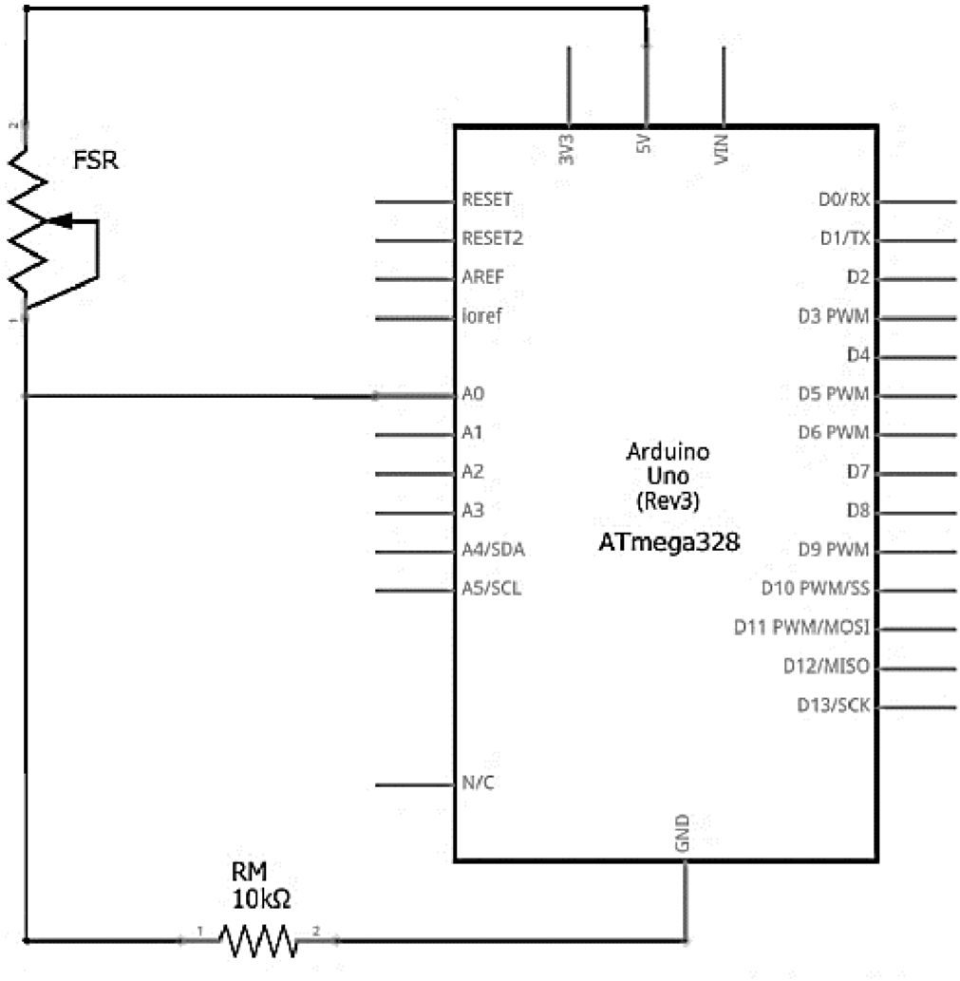

Fig.6 Circuit diagram of the prototype system

Repeat tested the sensor to check how it performed when there was a constant weight of 70 kg applied to the sensor for a long time. SAPCoS obtained the following result shown in Fig.7. The values read from the sensor increased between the 0th hour and 5th hour and became stable after the 6th hour.
Fig.7 Value changes when applying 70 Kg constant force

VIII. CONCLUSION AND FURURE WORK

The test model worked as expected . It can detect people sitting on the test seat, but from our observations there are two factors that may affect the reliability of the system that we need to consider. The first being passenger weight. The passenger could be an infant having a much different weight compared to an adult passenger, and the system might be unable to register that weight as a person. Despite lowering the threshold values of the system to allow lower weight detection, we came across some obstacles when the value was too low, for example: setting the lower end value of the threshold to 4 kg allowed us to detect a wider range of passenger ages, but on the other hand, the system lost the ability to distinguish between passengers and luggage that weighed over 4 kg. Moreover, the lower end threshold value reached a limit because of the cushion weight. Another point was the position of the seated passenger. Since the sensors had a sensing area of 39.6 x 39.6 mm., there was the possibility that passengers sit too far from the sensing area. When that happened, the cushion could not spread the force over the sensing area, and resulted in reading values of zero or very low. However, careful adjustment of the sensor’s mounting point as well as using sensors that had larger sensing areas reduced the possibility of false off-seat readings.

ACKNOWLEDGEMENT
Thank The Department of Computer Science at Kasetsart University for supporting this research.

REFERENCES
[1] Atmel. (2016, November). Atmel 8-bit AVR Microcontrollers ATmega328/P Datasheet Complete. Retrieved March 25, 2017, from http://www.atmel.com/Images/Atmel-42735-8-bit-AVR-Microcontroller-ATmega328-328P_datasheet.pdf
[2] Bernini, N., Bombini, L., Buzzoni, M., Cerri, P., & Grisleri, P. (2014). An embedded system for counting passengers in public transportation vehicles. 2014 IEEE/ASME 10th International Conference on Mechatronic and Embedded Systems and Applications (MESA). doi:10.1109/mesa.2014.6935562
[3] Interlink Electronics. (n.d.). FSR® 400 Series Data Sheet. Retrieved March 10, 2017, from https://www.interlinkelectronics.com/datasheets/Datasheet_FSR.pdf
[4] Interlink Electronics. (n.d.). FSR Integration Guide and Evaluation Parts Catalog with Suggested Electrical Interfaces. Retrieved March 10, 2017, from https://www.sparkfun.com/datasheets/Sensors/Pressure/fsrguide.pdf

